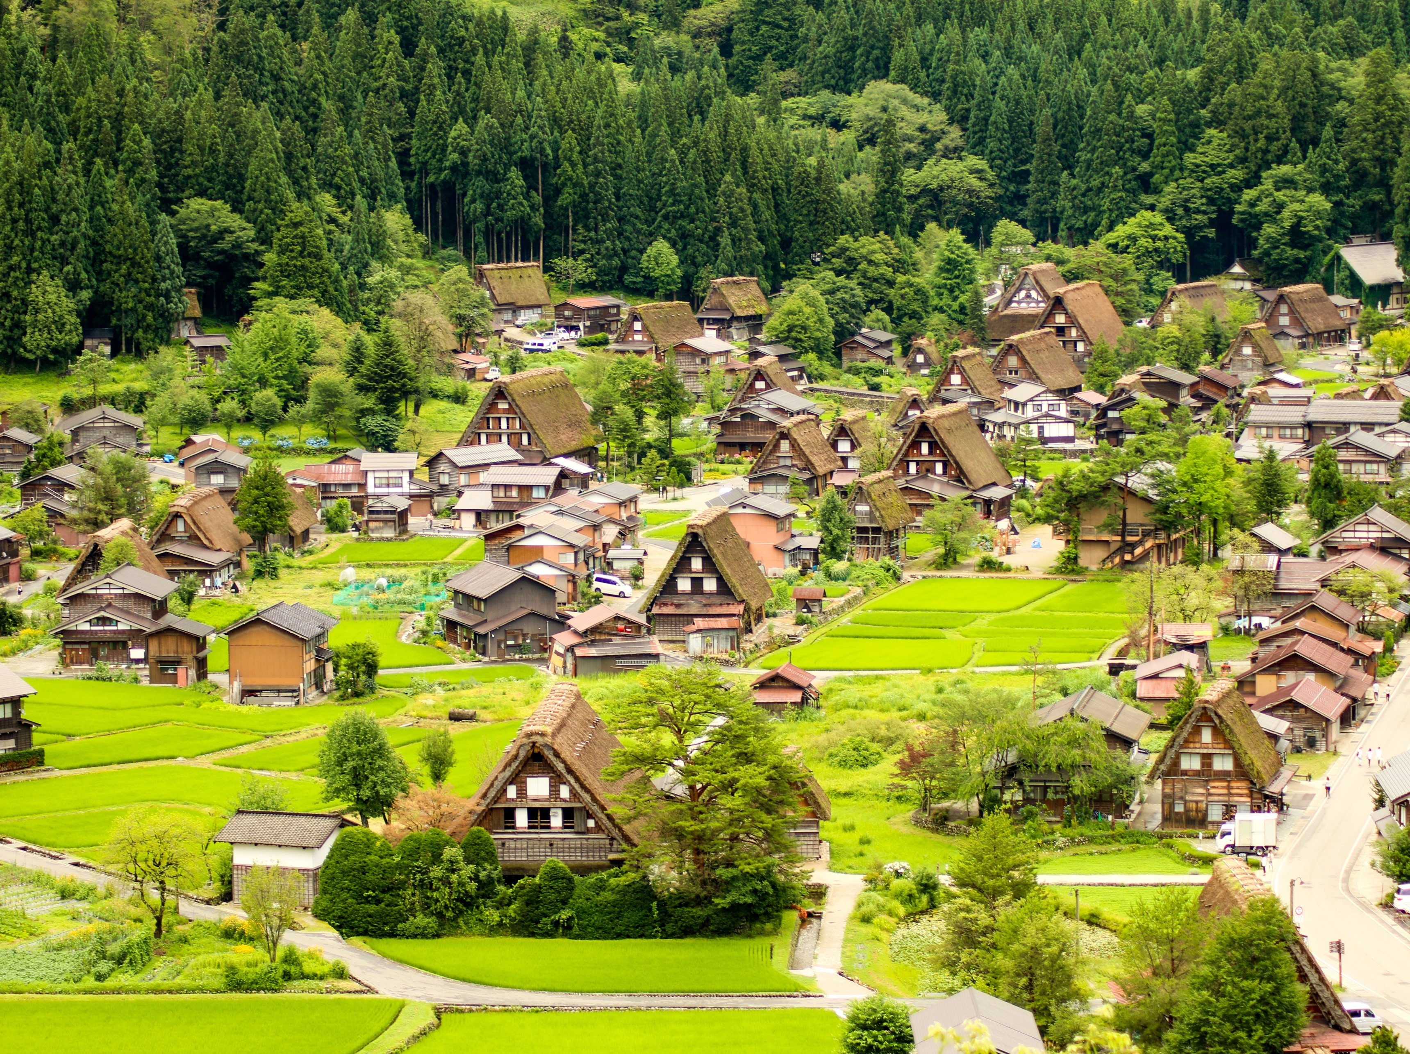
Best Tourism Villages by
UNWTO

Application Rationale
Application Rationale

This template must be completed and submitted in PDF within the section ‘Application Rationale’ (field 2.2.) of the online Application Form.
All questions are mandatory.
Please do not exceed the maximum length for each question. We suggest the use of the ‘Word Count’ function to ensure that limits are not exceeded.

Motivation Statement
- What is the village’s vision on the contribution of tourism for rural development?
Explain how the village sees the role of tourism as a driver for sustainable rural development (300 words maximum).

- What are the village’s goals in advancing tourism as a driver for rural development?
Explain which are the main goals of your tourism strategy and how these contribute to drive rural development (300 words maximum).

- Highlight two initiatives that you think will make a critical contribution to your objectives stated above. Creative and innovative approaches will be especially valued (300 words maximum).

- What are the village’s expectations on the impact from the designation as a Best Tourism Village by UNWTO?
Explain the main reasons behind the decision to submit the application to the Best Tourism Villages by UNWTO and the expected mid and long-term (3-5 years) impact of the designation for the development of the village through tourism (300 words maximum).

- What are the main contributions that the village could make to the Best Tourism Villages Network, if selected? (300 words maximum)

- How does tourism contribute to the advancement of the Sustainable Development Goals (SDGs) in the village?
Explain how the village sees the role of tourism as a driver for sustainable rural development in the context of the SDGs – which SDGs are more important and how you act to advance them (300 words maximum).

Commitment and Future Actions
A commitment to the sustainable conservation of the Best Tourism Villages by UNWTO label and active participation in the Best Tourism Villages Network must be included with the proposal translating the continued pledge of the village to the development of sustainable tourism.
When providing the following information, please provide realistic, coherent and feasible proposals which are also in line with the United Nations 2030 Agenda for Sustainable Development. It is recommended to describe the main planned initiatives in a meaningful manner rather than multiple theoretical lists of actions. In case of being awarded, the village will be expected to implement the measures, strategies and actions described and to report on its implementation via the compulsory Monitoring Report (please see Terms and Conditions for further information on the Monitoring Report).
For that purpose, please provide the following information:

- Identify and analyse threats and challenges to the sustainability of tourism development in the village (300 words maximum).

- What are the policies, strategies and actions that will be taken in the next five years and how will they respond to the threats identified? (300 words maximum)

- How will these contribute to the conservation of the cultural and natural assets and to the three dimensions – economic, social and environmental – of sustainable tourism? (300 words maximum)
- How are multi-stakeholders, including local communities, involved to support these actions? (300 words maximum)

- What actions would you like to seek funding and/or mobilize resources for at the local, national and/or international level and how? (300 words maximum)

- How will the village monitor the progress of these actions? (300 words maximum)

