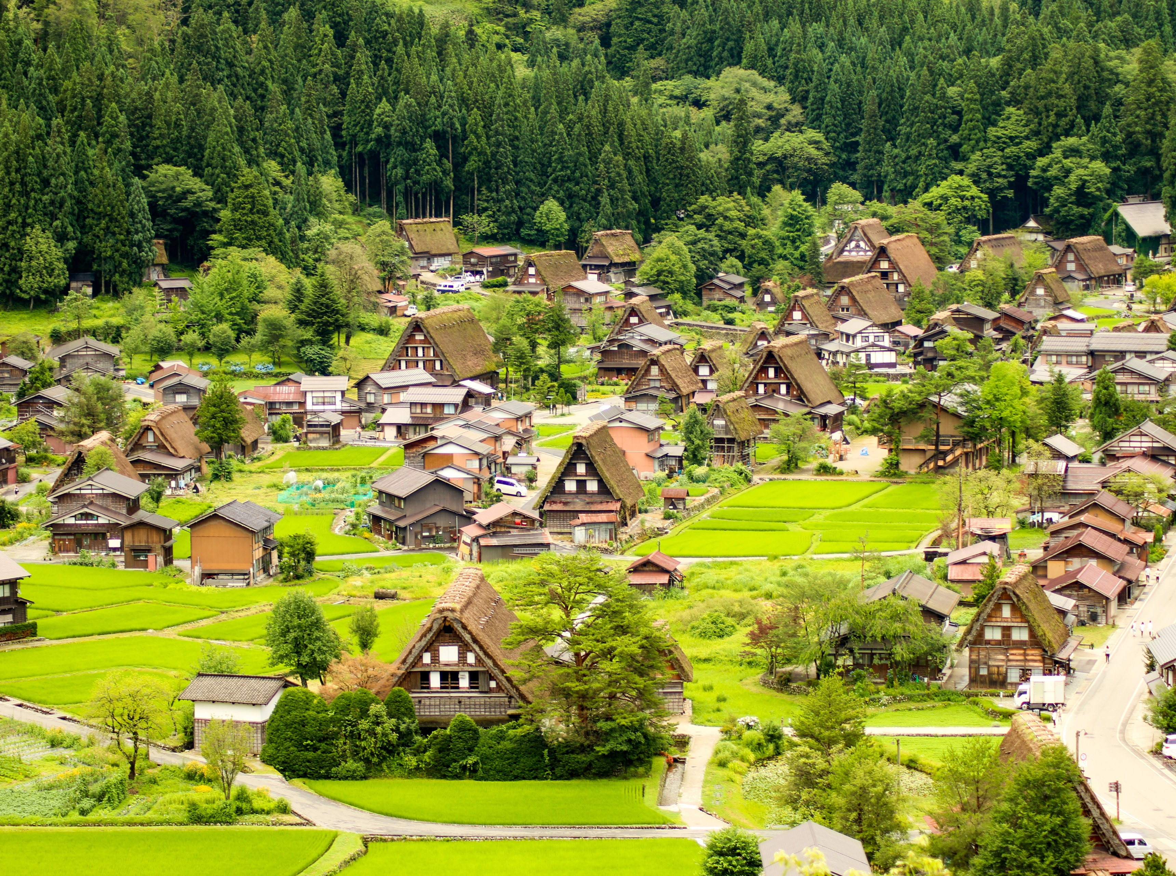
Best Tourism Villages
by UNWTO

Application Form

Best
Tourism Villages
by UNWTO

Application Form

Application Form

Before you submit your application, we invite you to carefully read the following documents (available at http://www.unwto.org/tourism-villages/):
- Terms and Conditions
- Guidelines for Application
- Application Rationale
- Areas of Evaluation
IMPORTANT NOTES:
- Applications must be submitted online.
- The online application form, the presentation and the Application Rationale must be submitted in English only. Information in any other language will not be considered.
- All supporting documents shall be submitted in English. If documents are only available in another language, please provide a short summary in English (not exceeding 300 words) and an audio-visual supporting documents (link to a website, photo or video). As much as possible relevant links are preferred to documents.
- All documents must be submitted in the format specified in the online application form and must not exceed the maximum length and/or size indicated. The title of each document should reflect the contents of the document.
- Make sure to have all mandatory documents ready for upload before submitting your application. Incomplete and/or late applications shall not be considered.
- Once an application is submitted, no changes can be made. The submitted application will be considered as the final version.
- Deadline for applications is 31 July 2021 (23:59 CET)
- All fields marked with an asterisk (*) are mandatory.

Basic Information
- Name of the village* |  | Open-ended Question
- Country* |  | Drop-down Question
- Population of the village (number of inhabitants) * | Considering that a maximum of 15.000 inhabitants is an eligibility pre-requisite, please indicate the number of inhabitants and submit/provide a supporting link/document of the population census for the village for the latest year available. | Open-ended Question + File upload /link
  - Contact information for representative in the village (highest authority)
- Title (Mr/Ms/Other)* |  | Field Questions
    - Family Name*
    - First Name*
    - Institution*
    - Position*
    - Address*
    - Telephone Number*
    - E-mail Address*
  - Contact information for the responsible for the application at the UNWTO Member State
The responsible for the application of the village will be the representative of the UNWTO Member State. This person will be responsible for the communication and coordination of all issues related to the candidacy.
- Title (Mr/Ms/Other)* |  | Field Questions
    - Family Name*
    - First Name*
    - Institution*
    - Position*
    - Address*
    - Telephone Number*
    - E-mail Address*

Application Rationale
Why do you consider that the village should be awarded as a Best Tourism Village?
2.1. Please explain in what ways the village fills in the objectives of the initiative – to promote tourism as a driver of sustainable tourism in all its aspects – economic, social and environmental.  For the purpose of this section, please upload a presentation (PowerPoint, Google Slides or similar) with a maximum of 10 slides.* | File Upload
2.2. Please upload the Application Rationale dully filled in PDF format * | File Upload

Areas of Evaluation
Please describe the main initiatives, policies, programmes, measures and projects relevant to assess each of the fields described below.
In this section, applicants are also invited to submit supporting documents for each area in which they present information. Failure to submit the supporting documents for the areas where information is provided will result in the impossibility to assess that area by the Advisory Board.
IMPORTANT:
- All supporting documents should have no more than 5 years and/or the document provided should still be valid at the moment of submitting the application.
- All supporting evidence documents shall be submitted in English. If documents are only available in another language, please provide a short summary in English (not exceeding 300 words) and an audio-visual evidence (link to a website, photo or video). As much as possible relevant links are preferred to documents.
3.1. Cultural and Natural Resources
The village has natural and cultural (tangible and intangible) resources recognized at national, regional or international level. This can include issues such as:
- The village has recognized cultural resources (tangible and intangible).
- The village has recognized natural resources.
3.1.1. Please provide a description of the existing recognized cultural (tangible and intangible) and natural resources. * (300 words maximum) | Open-ended question
3.1.2. Please submit a maximum of 2 relevant supporting documents such as links, official documents, presentations, brochures, communications materials, photos or videos, etc. | •File upload  •Relevant links
3.2. Promotion and Conservation of Cultural Resources
The village is committed to the promotion and conservation of its cultural resources which make it unique and authentic. This can include issues such as:
- The village disseminates and/or promotes policies, measures and initiatives aimed at the conservation of cultural resources.
- The village disseminates and/or promotes policies, measures and initiatives that value its cultural resources.
3.2.1. Please describe the main policies, measures and initiatives relevant to showcase how the village is committed to the promotion and conservation of its cultural resources which make it unique and authentic. * (300 words maximum) | Open-ended question
3.2.2. Please submit a maximum of 2 relevant supporting documents such as links, official documents, presentations, brochures, communications materials, photos or videos, etc. | •File upload  •Relevant links
3.3. Economic Sustainability
The village is committed to promote economic sustainability, supporting business development, entrepreneurship, value chain integration, investment and the positive impact of tourism in the local economy. This can include issues such as:
- The village disseminates and/or promotes policies, measures and initiatives to support the access to finance for tourism development.
- The village disseminates and/or promotes policies, measures and initiatives to support and encourage tourism investment.
- The village disseminates and/or promotes a framework that is conducive to business development, particularly for tourism Micro, Small and Medium Enterprises (MSMEs) and entrepreneurship.
- The village disseminates and/or promotes the cooperation with businesses and Academia for developing new products and business models.
- Tourism brings positive economic impact to the community, without decreasing the conventional economic activities such as agriculture, forestry, livestock and/or fisheries and their relevant processing industries.
3.3.1. Please describe the main policies, measures and initiatives relevant to showcase how the village is committed to promote economic sustainability supporting business development, entrepreneurship, value chain integration, investment and the positive impact of tourism in the local economy.* (300 words maximum) | Open-ended question
3.3.2. Please submit a maximum of 2 relevant supporting documents such as links, official documents, presentations, brochures, communications materials, photos or videos, etc. | •File upload  •Relevant links
3.4. Social Sustainability
The village is committed to promote social inclusion and equality by catalysing and spreading the benefits of tourism, leaving no one behind. This can include issues such as:
- The village disseminates and/or promotes policies, measures and initiatives to foster employment in the tourism sector.
- The village disseminates and/or promotes policies, measures and initiatives to advance women empowerment and gender balance in tourism.
- The village disseminates and/or promotes policies, measures and initiatives to support skills development, employment and entrepreneurship of youth (17-29 years old).
- The village disseminates and/or promotes policies, measures and initiatives, to foster opportunities for vulnerable populations: i.e., underrepresented residents from indigenous groups of ethnic minorities and persons with disabilities.
- The village disseminates and/or promotes policies, measures and initiatives for human resources, education and skills development, with particular focus in advancing innovation and reducing the digital skills gap.
- The village disseminates and/or promotes policies, measures and initiatives, to advance accessibility for travellers with specific access requirements.
- The tourism private sector is committed to Social Sustainability in line with the SDGs.
3.4.1. Please describe the main policies, measures and initiatives relevant to showcase how the village is committed to promote social inclusion and equality by catalysing and spreading the benefits of tourism.* (300 words maximum) | Open-ended question
3.4.2. Please submit a maximum of 2 relevant supporting documents such as links, official documents, presentations, brochures, communications materials, photos or videos, etc. | •File upload  •Relevant links
3.5. Environmental Sustainability
The village is committed to environmental sustainability through the promotion and/or dissemination of policies, measures and initiatives that advance the preservation and conservation of its natural resources and minimize the impact of tourism development on the environment. This can include issues such as:
- The village disseminates and/or promotes policies, measures and initiatives, for the preservation and conservation of natural resources.
- The village disseminates and/or promotes policies, measures and initiatives aimed at fighting climate change.
- The village disseminates and/or promotes policies, measures and initiatives, to reduce single-use plastics in tourism.
- The village disseminates and/or promotes policies, measures and initiatives, to monitor and reduce the impact of tourism on water consumption and the generation of sewage and solid waste.
- The village disseminates and/or promotes policies, measures and initiatives, for raising awareness of sustainable tourism among the sector’s strategic stakeholders, including visitors.
- The tourism private sector is committed to Environmental Sustainability in line with the SDGs.
3.5.1. Please describe the main policies, measures and initiatives relevant to showcase how the village is committed to environmental sustainability through the promotion and/or dissemination of policies, measures and initiatives that advance the preservation and conservation of its natural resources and minimize the impact of tourism development on the environment. * (300 words maximum) | Open-ended question
3.5.2. Please submit a maximum of 2 relevant supporting documents such as links, official documents, presentations, brochures, communications materials, photos or videos, etc. | •File upload  •Relevant links
3.6. Tourism Potential & Development and Value Chain Integration
The village has significant market potential and tourism resources. It further promotes the enhancement of the tourism value chain and the competitiveness of the destination in areas related to market access, marketing and promotion, innovation, product development and quality. This can include issues such as:
- The village is integrated into an area with wider tourism attractions (e.g. is part of a thematic national, regional or international route, of a cluster of villages with common natural and cultural values, a natural park, etc).
- The village promotes and supports the development of competitive, sustainable, and innovative products and experiences and fosters the integration of tourism with all other sectors enhancing its value chain.
- The village has accommodation options that reflect rural and local values.
- The village has eating options with local gastronomy and traditional culinary culture.
- The village has and promotes products and activities related to local traditions and facilitates their purchase by local businesses and by tourists.
- The village implements or advocates for the implementation of tourism quality standards and certification systems among tourism businesses and services providers.
- The village has tourism signage.
- The village has capacity to host events and/or has developed relevant events, particularly related to local culture, knowledge and products.
- The village has/takes an active part in marketing and promotion plans/initiatives.
- The village tourism offer is well represented in travel distribution channels and in promotional websites.
- The village is committed to a transformational strategy, fostering innovation in its tourism vision, approach and products offered.
3.6.1. Please provide a description of the village’s market potential and tourism. Describe the main policies, measures and initiatives relevant to showcase how the village is committed to the enhancement of the tourism value chain and the competitiveness of the destination in areas related to market access, marketing and promotion, innovation, product development and quality.* (300 words maximum) | Open-ended question
3.6.2. Please submit a maximum of 2 relevant supporting documents such as links, official documents, presentations, brochures, communications materials, photos or videos, etc. | •File upload  •Relevant links
3.7. Governance and prioritization of tourism
The village is committed to make Tourism a strategic pillar for rural development. It further promotes a governance model based on public-private partnerships, cooperation with other government levels and the engagement of the community in tourism planning and development. This can include issues such as:
- The village has a dedicated structure for tourism development and management (public, private or public-private).
- The village disseminates and/or promotes policies, measures and initiatives to enhance the public and the private sector cooperation.
- The village is part of the national or regional tourism plan, programmes or mechanisms and promotes multi-level government coordination.
- The village disseminates and/or promotes policies, measures and initiatives, supporting the participation of residents in tourism planning and development. It has implemented measures that contribute to local well-being and satisfaction.
- The village disseminates and/or promotes policies, measures and initiatives for tourism awareness among the community.
- The village disseminates and/or promotes rural-urban linkages and partnerships and recognizes the strong interaction with urban destinations as partners in its tourism development.
3.7.1. Please describe the main policies, measures and initiatives relevant to showcase how the village is committed to make tourism a strategic pillar for rural development and how the village promotes a governance model based on public-private partnerships, cooperation with other government levels and the engagement of the community in tourism planning and development.* (300 words maximum) | Open-ended question
3.7.2. Please submit a maximum of 2 relevant supporting documents such as links, official documents, presentations, brochures, communications materials, photos or videos, etc. | •File upload  •Relevant links
3.8. Infrastructure and connectivity
The village has infrastructure to facilitate access and communications that improve the wellbeing of rural communities, business development as well as the visitor experience. This can include issues such as:
- The village has transport infrastructure to facilitate connectivity.
- The village has communications and digital infrastructure.
- The village has coverage for electronic payments among tourism service providers.
3.8.1. Please provide a description of the village’s infrastructure and how it facilitates access and communications that improve the wellbeing of rural communities, business development as well as the visitor experience * (300 words maximum) | Open-ended question
3.8.2. Please submit a maximum of 2 relevant supporting documents such as links, official documents, presentations, brochures, communications materials, photos or videos, etc. | •File upload  •Relevant links
3.9. Health, Safety and Security
The village has health, safety and security systems to safeguard residents and tourists. This can include issues such as:
- The village has/is part of a public health, safety and security plan/system.
- The village has/is close to health care services and providers.
- In case of vulnerability to natural disasters, the village has/is part of an emergency plan
3.9.1. Please provide a description of the village’s health, safety and security systems to safeguard residents and tourists * (300 words maximum) | Open-ended question
3.9.2. Please submit a maximum of 2 relevant supporting documents such as links, official documents, presentations, brochures, communications materials, photos or videos, etc. | •File upload  •Relevant links

Compliance Framework
How did you learn about the Best Tourism Villages by UNWTO pilot initiative? | - UNWTO website  - Social Media  - Direct Communication from UNWTO  - Press  - Event  - Recommendation from colleague or partner  - Other  - … | Multiple Choice Question

Before submitting the application, please make sure you have uploaded all the required documents in the specified format as listed below:
- Link or supporting document evidence with population census of the village for the latest year available reflecting the number of inhabitants (Field 1.3.)
- Presentation (Field 2.1.)
- Application Rationale completed (Field 2.2.)
1. I am/We are aware and accept the Statutes of UNWTO and the Global Code of Ethics for Tourism * | ☐  YES
2. I am/We are aware and accept to comply with the Terms and Conditions of ‘Best Tourism Villages by UNWTO’ pilot initiative. Accordingly, I/we recognize that UNWTO reserves the right to suspend or exclude a village from ‘Best Tourism Villages by UNWTO’ Label and/or Upgrade Programme and/or Network at any time in case of breach of these Terms and Conditions, for not meeting the requirements for joining the initiative for any other reason duly justified. * | ☐  YES
3. I/We understand and accept that the village, once officially a member of ‘Best Tourism Villages by UNWTO’ Network may mention its membership as such. It may therefore use after its name the mention “Member of Best Tourism Villages by UNWTO Network”. Any use of UNWTO’s signs (name, emblem, flag or acronym) shall be subject to prior written authorization by UNWTO and in full compliance with the terms and conditions in accordance with UNWTO Terms of Use. * | ☐  YES
4. By becoming a Member of ‘Best Tourism Villages by UNWTO’ Network, the village accepts to comply with the terms and conditions established by the UNWTO, in particular on the use of UNWTO signs and the prohibition to be involved in any activity that could be opposed to the objectives or principles of the UNWTO or the UN or that could adversely reflect upon the UNWTO.* | ☐  YES
UNDERTAKING
I, hereby, declare that all the information provided above is true and correct to the best of my knowledge and that I have read, understood and accepted the Terms and Conditions and agree to all of the terms therein. Should I fail to adhere to the conditions set out by said Terms and Conditions, I understand that the UNWTO reserves the right to dismiss my application.* | ☐  YES
DATA PROTECTION
1. By submitting their application, participants acknowledge that referenced projects are their own originals and/or they own the necessary right to ownership or property rights thereover. Participants agree to hold harmless UNWTO from any and all losses, claims, damages, expenses or liabilities which could arise in relation to intellectual property rights or personal data of third parties in relation to the applications submitted. UNWTO shall not claim any property on the initiatives submitted or any other industrial or intellectual property contained in their application. Participants do not cede UNWTO industrial or intellectual property rights arising as a result of their applications.* | ☐  YES
2. By submitting their application, participants expressly grant their consent to the use of the name or their village and initiatives in connection with the ‘Best Tourism Villages by UNWTO’ pilot initiative and the recording and maintenance of related files. Participants may exercise their rights to access, modify, cancel and oppose the processing of their personal details by sending an email to besttourismvillages@unwto.org indicating which right they wish to exercise and attaching a copy of their passport, national ID card or equivalent documentation.* | ☐  YES
☐ I agree*

Name**
Organization *
Position*
Country*
Date*

**The person submitting the application is the responsible for the application at the UNWTO Member State

With the vision of making tourism a positive force for transformation, rural development and community wellbeing, the Best Tourism Villages by UNWTO pilot initiative seeks to advance the role of tourism in valuing and safeguarding rural villages along with their associated landscapes, knowledge systems, biological and cultural diversity, local values and activities.

The World Tourism Organization (UNWTO), a United Nations specialized agency, is the leading international organization with the decisive and central role in promoting the development of responsible, sustainable and universally accessible tourism. It serves as a global forum for tourism policy issues and a practical source of tourism knowhow. Its membership includes 159 countries, 6 territories, 2 permanent observers and over 500 Affiliate Members.

World Tourism Organization (2016) UNWTO Basic Documents, Volume I ‐ Statutes, Rules of Procedure, Agreements, fifth edition, UNWTO, Madrid. https://doi.org/10.18111/9789284417513
https://webunwto.s3.eu-west-1.amazonaws.com/imported_images/37802/gcetbrochureglobalcodeen.pdf
A/RES/601(XIX) available at https://www.e-unwto.org/doi/pdf/10.18111/unwtogad.2011.1.q143011gl1856q48

